Project Title

Author Name

*December 201X*

**Interim Project Report**

Computing Science and Mathematics

University of Stirling

# Introduction

For editorial consistency, it is important to use Word styles properly. Word 2003 onwards has so-called quick styles. If the styles referred to below are not visible on the *Home* ribbon in the *Styles* category, choose *Apply Styles* from the down arrow at the bottom right of the *Styles* category. Styles can then be applied from the drop-down box. To make a style visible as a quick style, choose *Apply Styles*, then click *Styles* (the *AA* icon), then click on the drop-down list for a style, and then *Add to Quick Style Gallery*.

Chapters are entered using the *Heading 1* paragraph style; they start on a new page. The paragraph after a heading automatically uses the *Body First* paragraph style.

However most text uses the *Body Text* paragraph style like this paragraph. Ordinary text appears as 11 point Times New Roman, single-spaced, single-sided pages.

In general, use the default spacing that headings and paragraphs give you. Avoid using newlines or spaces to format text. If you need to use quotes, preferably use single curly quotes ‘…’.

## Background and Context

Describe the problem that you are tackling. Sections are entered using the *Heading 2* paragraph style.

## [Scope](http://www.cs.stir.ac.uk/~kjt/research/conformed.html) and Objectives

Define the scope and objectives of your project. Define the expected results and how others will gain from the work.

# State-of-The-Art

Discuss the work of others in the same area as your project. Show critical awareness of what others have done, and how you hope to extend or complement existing capabilities. Give references to other work by using cross-references like [2].

It is important to write a *critical* literature review that identifies gaps in current solutions and that clearly shows how the project was driven to address these gaps. This chapter should therefore feed into well-defined requirements for the project. Avoid a banal description of related work that does not carefully analyse its strengths and weaknesses.

# Methodology

Explain how you are tackling the project. Describe any special software or hardware that you are using. Discuss the techniques you have chosen, and the developments you are undertaking. Demonstrate how you are performing the project as a computing professional (i.e. application of systematic techniques, awareness of relevant professional issues).

## Data Collection

Subdivide lengthy text into sections.

### First Subsection

If necessary, also use subsections. Subsections are entered using the *Heading 3* paragraph style.

#### First Subsubsection

If you really need subsubsections, enter these using the *Heading 4* paragraph style.

As an example of a figure, consider Figure 1. Captions are entered using the *Figure* paragraph style. Use automatic figure numbering and cross-references. Let large figures float to the top of the next page rather than having a big gap in the text. If you need something centred as for a figure, use the *Body Centre* paragraph style.

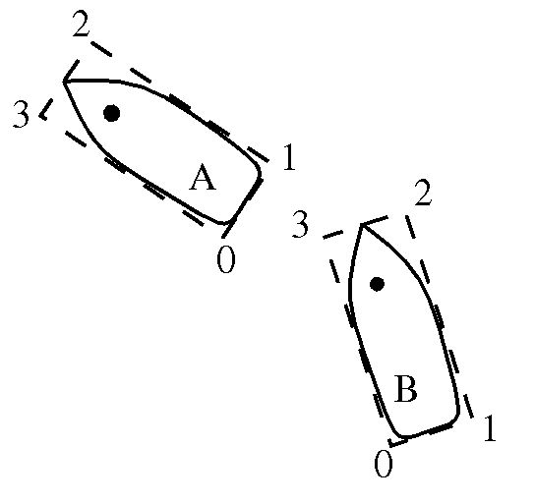

1. Highly Technical Diagram

## Fi

## Website Development

## Fi

# Prototype

Describe the prototype you have implemented.

# Interim Plan

## Updated Project Plan

Give an updated plan for the remainder of the project. This should identify the remaining pieces of work and when you plan to complete them.

## Updated Project Deliverables

Update the remaining deliverables of the project. In particular, describe what you will demonstrate when the final report is due.

References

Use the *Reference* paragraph style to enter and cross-reference document references. Books [1], standards [2], reports [3], journal articles [4], conference papers [5], and web pages [6] are conventionally presented in slightly different ways.

1. Greene, D. and Williams, P. C. *Linear Accelerators for Radiation Therapy*, Second Edition. IOP Publishing Ltd., Bristol and Philadelphia, 1997.
2. ISO. *Language Of Temporal Ordering Specification*, ISO 8807, International Organization for Standardization, Geneva, 1989.
3. Jacobson, J. and Andersen, O., editors. *Software Controlled Medical Devices*. SP Report 1997:11, Swedish National Testing and Research Institute, Sweden, 1997.
4. Turner, K. J. The Rules for Sailing Races on PDAs, *J. Navigation*, 23(5):114-240, May 2002.
5. Ji, H. and Turner, K. J. Specification and Verification of Synchronous Hardware using LOTOS. In Wu, J. Chanson, S. T. Gao, Q. editors, *Proc. Formal Methods for Protocol Engineering and Distributed Systems* (FORTE XII/PSTV XIX), pages 295-312, Kluwer Academic Publishers, London, UK, October 1999.
6. University of Stirling. Computing Science and Mathematics Research Home Page, [*http://www.cs.stir.ac.uk/research*](http://www.cs.stir.ac.uk/research), October 2008.